ASSIGNMENT – I
Project Requirements Specification Hotel Room Reservation System

Group Members
Name | Student ID
Sobuj Hosen | e2403514
Anush Gotame | e2401841

Identify the Stakeholders and User Needs

The successful development and deployment of the Hotel Room Reservation System requires a comprehensive understanding of the individuals and entities that will interact with, benefit from, or evaluate the application. We have identified six primary stakeholder groups. Their distinct needs, expectations, and responsibilities serve as the foundational drivers for the system's functional and non-functional requirements.

Stakeholder Profiles and Responsibilities
Customers (Guests): The primary end-users of the system. They expect an effortless, secure, and intuitive way to browse rooms, check dates, and book — with their privacy protected and their booking confirmed right away.
Administrators (Hotel Management): The personnel responsible for the overarching configuration and inventory of the hotel. They require complete CRUD (Create, Read, Update, Delete) capabilities to manage room types, adjust pricing, and oversee system data without needing technical database skills.
Receptionists (Front Desk Staff): The operational staff who interact with customers on-site. They require real-time oversight of current and upcoming reservations. Their workflow demands the ability to quickly verify customer identities, confirm booking details, and modify existing reservations (e.g., changing room assignments or dates) to accommodate guest needs.
Development Team (Us): Responsible for designing, implementing, testing, and deploying the software. We require clear requirements, a manageable tech stack (MERN), and automated CI/CD pipelines to ensure collaborative, error-free integration of code.

1.2 Main User Needs Summary
Stakeholder |  | Main System Needs and Expectations
Customers |  | Easy and fast account creation; intuitive search filters for room availability; clear presentation of room details and pricing; a secure and straightforward checkout/booking process; the ability to view past and future reservations; protection of personal data.
Administrators |  | Secure admin dashboard, simple forms to add or remove rooms, and a clear view of all inventory
Receptionists |  | A sorted list of all bookings, quick customer search, and tools to edit or cancel reservations
Stakeholder | Main System Needs and Expectations
Dev Team | Well-defined modular architecture; clear separation of concerns between frontend and backend, reliable automated testing mechanisms,maintainable and thoroughly documented codebase.

Define the Overall Application Requirements

Based on the stakeholder analysis, the application requirements are partitioned into Functional Requirements (what the system must specifically do) and Non-Functional Requirements (how the system must behave in terms of quality, performance, and constraints).

Functional Requirements (FR)

User Authentication and Profile Management
ID | Requirement Description
FR-USR-  01 | The system shall allow users to register for a new account using a unique email address and a secure password.
FR-USR-  02 | The system shall authenticate users via a secure login mechanism, verifying email and password credentials.
FR-USR-  03 | The system shall assign and enforce role-based access levels (Customer, Receptionist, Administrator) upon authentication.
FR-USR-  04 | The system shall provide a mechanism for authenticated users to securely log out and terminate their active session.

Room and Inventory Management (Admin Level)
ID | Requirement Description
FR-INV-  01 | Administrators shall be able to add new room entries to the database, specifying Room Number, Type (e.g., Single, Suite), and Price per Night.
FR-INV-  02 | Administrators shall be able to view a comprehensive list of all rooms currently registered in the system.
FR-INV-  03 | Administrators shall be able to update the details of an existing room (e.g., modifying the price or changing the room type).
FR-INV-  04 | Administrators shall be able to soft-delete or remove a room from the available inventory.

Reservation and Booking Engine
ID | Requirement Description
FR-RES-  01 | Customers shall be able to search for available rooms by specifying a desired date range.
FR-RES-  02 | The system shall accurately filter out rooms that are already booked for any overlapping dates during a customer's search.
FR-RES-  03 | Customers shall be able to finalize a reservation for an available room, generating a persistent booking record.
FR-RES-  04 | Customers shall be able to view a dedicated dashboard displaying their own upcoming and historical reservations.
FR-RES-  05 | Receptionists shall be able to view a master list of all reservations made by all customers across the system.
FR-RES-  06 | Receptionists shall be able to modify the parameters of a customer's reservation (e.g., altering dates or room assignment).

Non-Functional Requirements (NFR)

Performance Requirements
Response Time: Database queries, particularly for room availability searches, must be highly optimized. The API should respond to standard GET and POST requests within 800 milliseconds under normal load conditions.
Frontend Rendering: The React application must achieve a First Contentful Paint (FCP) of under 1.5 seconds to prevent user abandonment.
Concurrency: The Express server and MongoDB cluster must be capable of handling at least 50 concurrent active users without degrading response times beyond 2 seconds.

Usability Requirements
Interface Intuitiveness: The application must utilize familiar design patterns (e.g., standard navigation bars, clear Call-to-Action buttons for booking). Users should be able to complete a room booking in no more than 4 or 5 clicks from the homepage.
Responsiveness: The frontend UI must be fully responsive, ensuring seamless operation on desktop monitors, tablets, and mobile smartphone screens.
System Feedback: The UI must provide immediate, unambiguous visual feedback for all user actions. This includes loading spinners during asynchronous API calls and toast notifications for successes or errors (e.g., "Invalid Credentials" or "Booking Confirmed").

Reliability and Availability
Uptime: The application architecture should support a simulated uptime of 99.9%.
Fault Tolerance: If the database connection drops, the Express backend must catch the error and return a standardized HTTP 500 response with a graceful error message, rather than crashing the Node process.
Data Consistency: The system must adhere strictly to ACID properties for transactions, ensuring that two customers cannot double-book the exact same room for the exact same date.

Security Requirements
Password Protection: Plain-text passwords must never be stored in the database. All user passwords must be cryptographically hashed and salted using the bcryptjs library prior to MongoDB insertion.
Session Security: State and authentication must be managed via JSON Web Tokens (JWT). Tokens must have a strict expiration time (e.g., 24 hours) and be passed securely via HTTP headers.
Access Control: The Express API must implement strict routing middleware to verify the role payload inside the JWT. A Customer attempting to access an Administrator route (e.g., DELETE /api/rooms/:id) must be immediately rejected with an HTTP 403 Forbidden status.
Network Security: The MongoDB Atlas database must be protected via an IP Access List, restricting connections strictly to authorized deployment and development environments.

Maintainability Requirements
Modular Architecture: The codebase must enforce strict separation of concerns following the MVC (ModelView-Controller) pattern. React components, Express controllers, Express routes, and Mongoose schemas must reside in dedicated directories.
Version Control: All development must be tracked via Git, utilizing feature branches, standardized commit messages, and Pull Requests to the main branch.
Code Readability: Code must be commented, and variable naming conventions must be standardized (e.g., camelCase for JavaScript variables, PascalCase for React components) to ease future modifications by teammates.

Compatibility and Integration
Browser Support: Works on Chrome, Firefox, Safari, and Edge.
API Standards: RESTful architecture using standard HTTP verbs (GET, POST, PUT, DELETE) and JSON payloads.

Constraints
Infrastructure Limitations: Limited by MongoDB Atlas Free Tier (500MB storage, limited connection pool).

Partition the Application into Logical Subsystems

To reduce complexity, distribute workload among team members, and adhere to best practices for maintainability, the application is partitioned into three major logical subsystems characteristic of the MERN stack.

Client Presentation Subsystem (React / Vite)
Main Purpose: The user-facing layer. Handles page rendering, local state, form validation, and routing (Customer Dashboard vs. Admin Dashboard).
Inputs: User actions (clicks, typing), JWT tokens, and JSON data from the API.
Outputs: Rendered HTML/CSS on screen and HTTP requests to the API.
Specific Requirements: Uses React Router for single-page navigation. UI elements (like "Add Room") are shown or hidden based on the user's role.

Application Logic & API Subsystem (Node.js / Express)
Main Purpose: To act as the central brain and security checkpoint of the application. It listens for incoming client requests, validates the data and permissions, executes business logic, interacts with the database, and formats the responses.
Inputs: HTTP requests (GET, POST, PUT, DELETE) containing URL parameters, query strings, JSON body payloads (e.g., registration details, booking dates), and authorization headers.
Outputs: HTTP status codes (200, 201, 400, 401, 403, 404, 500) and JSON responses.
Specific Requirements: Must implement Express middleware for global error handling and CORS (CrossOrigin Resource Sharing) policies. Must abstract business logic into separate Controller functions to keep Route files clean and maintainable.

Data Persistence Subsystem (MongoDB Atlas / Mongoose)
Main Purpose: Secure, schema-validated storage that survives server restarts..
Inputs: Mongoose queries and commands from the Express server.
Outputs: BSON documents (Users, Rooms, Reservations) and operation statuses.
Specific Requirements: Schema-level validation (e.g., valid emails, unique room numbers). Uses ObjectIDs to link Reservations to Users and Rooms

Quality Function Deployment (QFD) Analysis

Quality Function Deployment (QFD) is utilized here to systematically translate subjective stakeholder needs into objective, measurable technical specifications. By analyzing the relationship between what the user wants and how the system will achieve it, we can prioritize development tasks effectively. In the table below, stakeholder needs are assigned an Importance rating on a scale of 1 to 5 (where 5 is paramount), which informs the overall technical priority.

Stakeholder  Need | Importance  (1-5) | Technical / System  Requirement

Protection of personal data and accounts | Must have | Bcrypt hashing algorithms and JSON Web Token  (JWT) session generation.
Strict boundary between Admins and Customers | Must have | Express routing middleware that parses JWT payloads to enforce role checks.
Fast and accurate room availability  search | Good to have | Optimized MongoDB  query structures utilizing indexed date fields.
Simple and intuitive booking process | Good to have | Responsive React UI with clear visual hierarchies and robust form validation.
System  reliability and crash prevention | Good to have | Comprehensive backend error trapping (Try/Catch blocks) and database fallback mechanisms.
Demonstrable progress and code sharing | Must have | Implementation of Git version control and  GitHub Actions for CI/CD.
Organized, understandable code | Exiciting | Strict adherence to MVC architectural patterns and modular file structures.

QFD Conclusion: Security (authentication/authorization) and data integrity (booking logic) are the highest priorities. Because the course emphasizes CI/CD and database persistence, setting up MongoDB schemas and the GitHub Actions pipeline are critical early tasks. UI polish is important but comes after the API and database layers are secure and working.

System Diagrams

To further explain the system's architecture and behavioral flow, visual models have been constructed. The Use-Case Diagram maps out the scope of system functionalities categorized by actor privileges, while the Sequence Diagram traces the execution of the system's most complex operation: the room reservation process.

Use-Case Diagram
The use-case diagram shows the outer limits of the Hotel Reservation System. It makes clear which types of users—called actors—are allowed to perform which actions. The diagram also shows the idea of “least privilege,” meaning each user gets only the access they need and nothing more. Customers are kept fully inside their own area: they can search for rooms and make and manage their own bookings, but they cannot go beyond that. The Administrator has broad control over the system’s room inventory and setup, so they can manage the main infrastructure. The Receptionist sits in the middle like a bridge: they can read and change customer reservations to help with daily hotel work, but they cannot access or change the core system configuration.
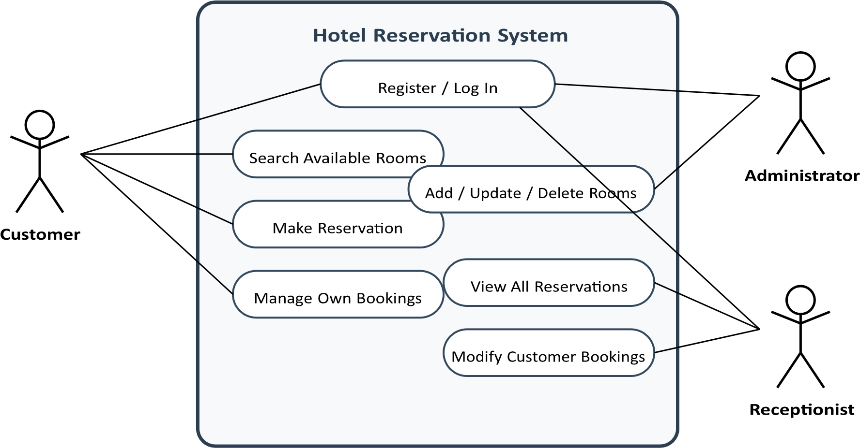
Figure 1. Unified Use-case diagram of the Hotel Reservation System depicting role isolation.

Sequence Diagram: The Reservation Flow
The sequence diagram shows, in order and step by step, how a normal core business process happens: a Customer starts a room reservation and completes it. It also shows how closely the three logical subsystems are connected and depend on one another.
The process starts in the Presentation Tier, which is the part the user sees and interacts with. From there, the request moves into the secure API Application Tier, where it is processed and checked/validated. Next, the request goes down to the Data Persistence Tier, where the data is verified and changed or saved. Finally, the result travels back up through the layers, and the end user is shown a confirmation.
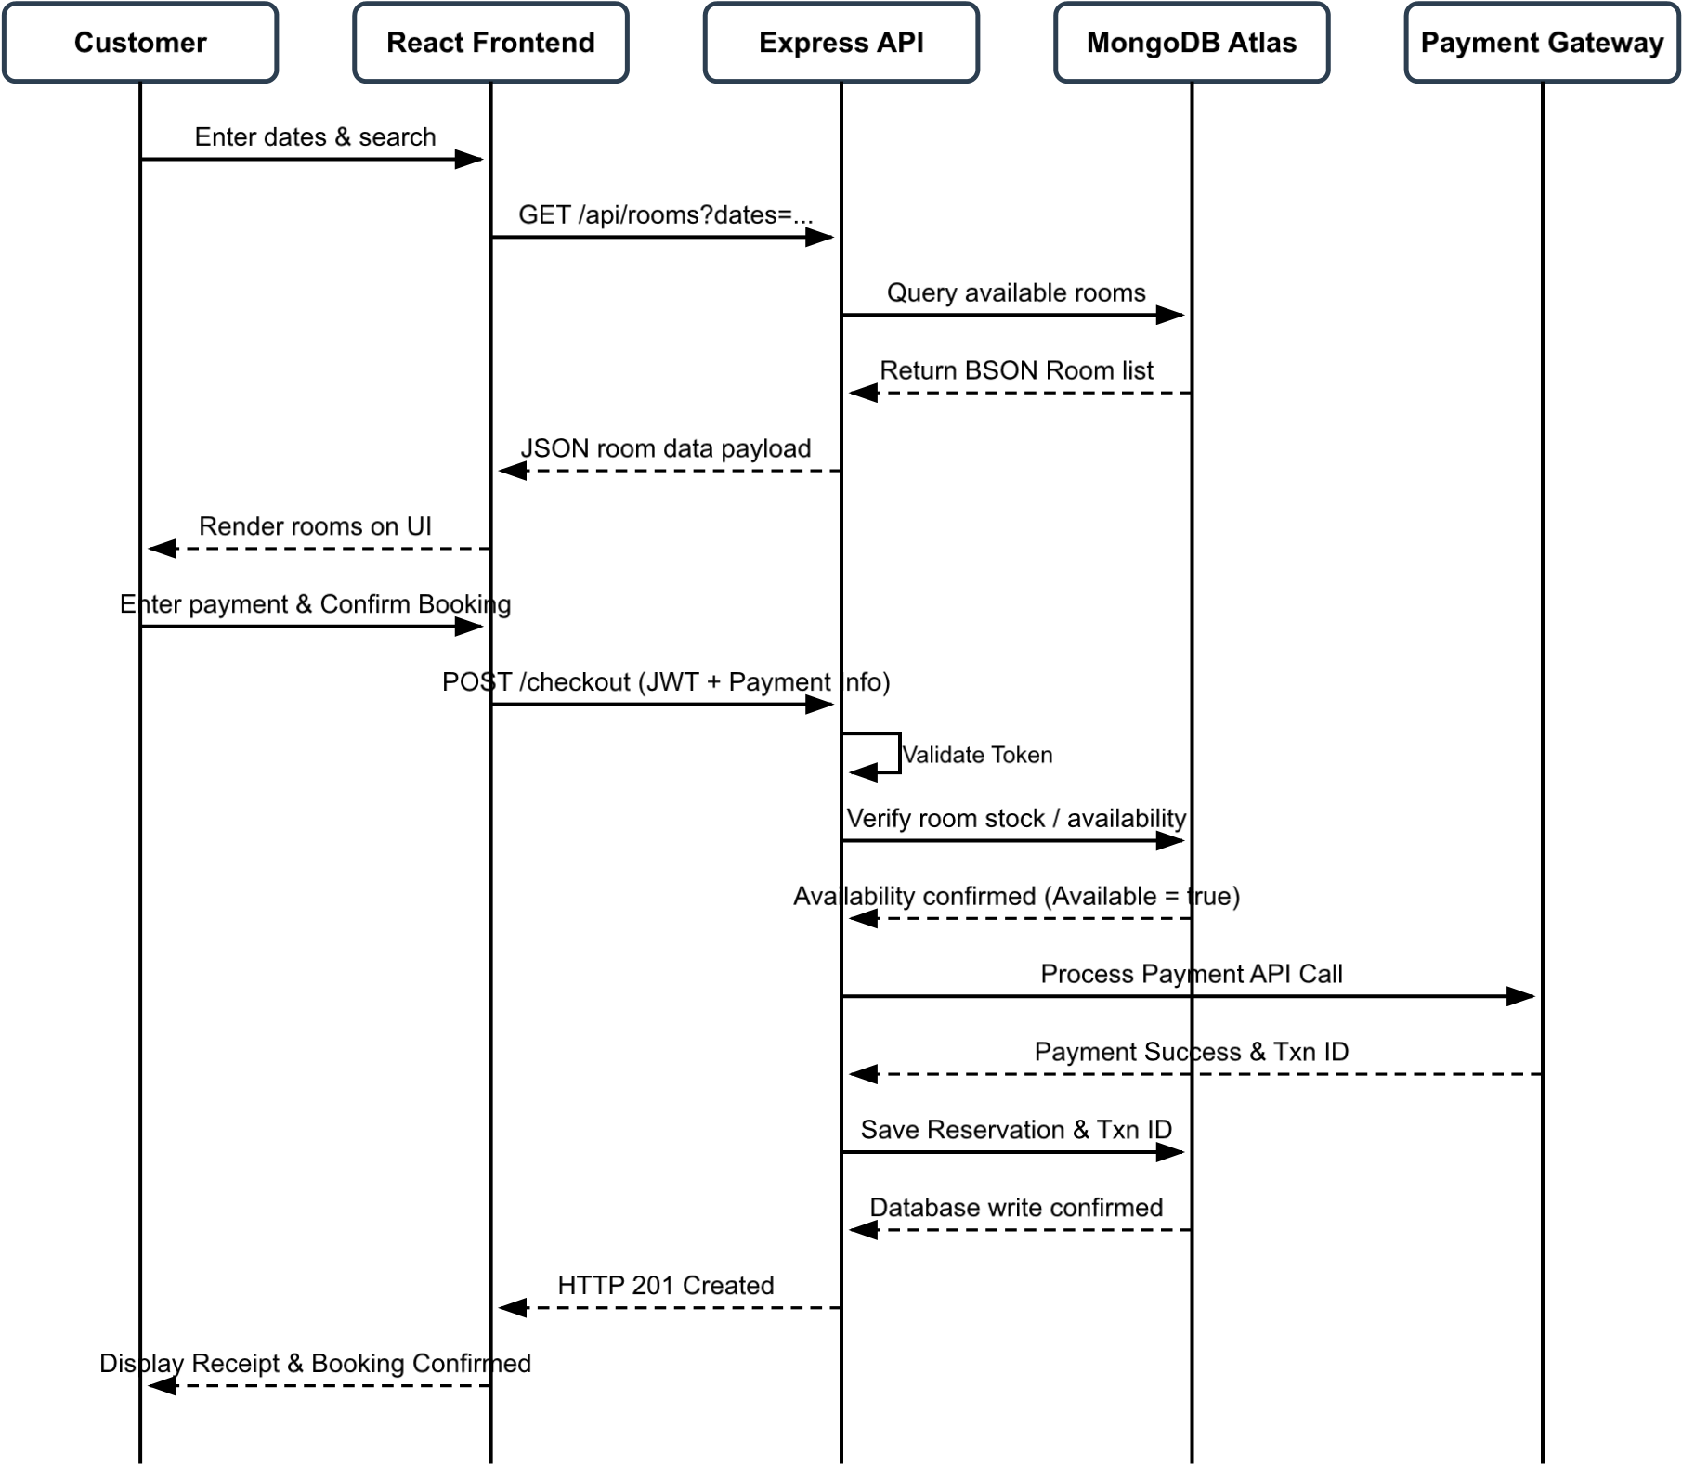
Figure 2. Sequence Diagram illustrating the communication flow for creating a new reservation.

Conclusion

The requirements specification for the Hotel Room Reservation System provides a complete blueprint for executing the project successfully. By identifying the needs of Customers, Receptionists, and Administrators, the team ensured the system delivers focused value while keeping each role’s access secure and separate. The Functional Requirements give a clear, practical roadmap for building features, while the Non-Functional Requirements set firm standards for performance, data integrity, and MERN stack architecture. Using Quality Function Deployment (QFD), the team linked customer expectations to technical needs and prioritized strong JWT authentication and optimized MongoDB queries over less important cosmetic features. Dividing the system into separate React, Express, and Database subsystems keeps the code modular and easy to maintain, and it fits the assignment’s requirement for GitHub CI/CD integration. Moving forward, these documented requirements will serve as a fixed benchmark against which all future Sprint deliverables, testing, and the final production build will be measured.

